E-Commerce Category Sales Analysis

SUBJECT: power BI Reports
Instructor Name:
Zeeshan Saleem Sahib
Madam Aleena

SUBMITTED BY:
Muhammad Fahad Malik

Overview:
This Power BI project presents an interactive 4-page dashboard analyzing six months of sales data for three major product categories Men’s Fashion, Beauty & Grooming, and Kids & Baby.
The report allows users to explore sales trends, customer engagement, and product performance through dynamic charts, slicers, and time-based comparisons.
A Calendar table was linked to the main dataset to enable accurate time-based analysis.
Using DAX formulas, important KPIs such as Total Sales, Products Sold, and Total Customers were calculated.
Each page provides specific insights for a category with visually appealing layouts and color themes for clarity and easy interpretation.

1. Pbix File of Project:
Here is the Pbix file of project :

2. Pdf file of Project:
Here is the pdf file of Power Bi capstone project.

1. Project screenshots:
Here is the Screenshots of project report.

1. Activity 1: Power Query
Here is the screenshots of activity 1.
- Dataset Table Screenshot:
Screenshot shows applied steps in the right pane.

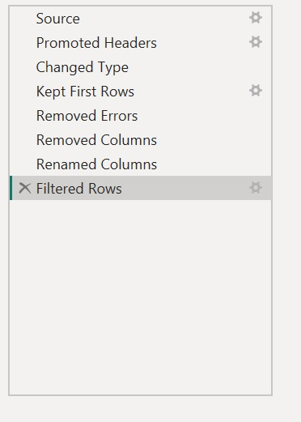

- Calendar Table Screenshot:
Screenshot shows applied steps in the right pane of calendar table data.

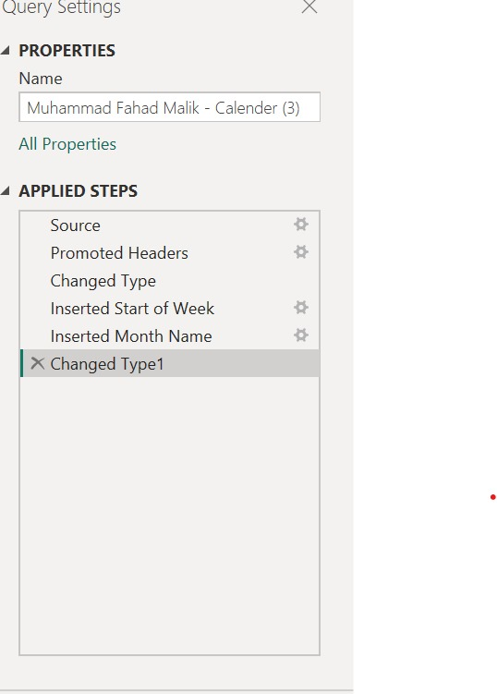
- Relationship Screenshot:
Relationship model view shown must clearly show one to many relationship.

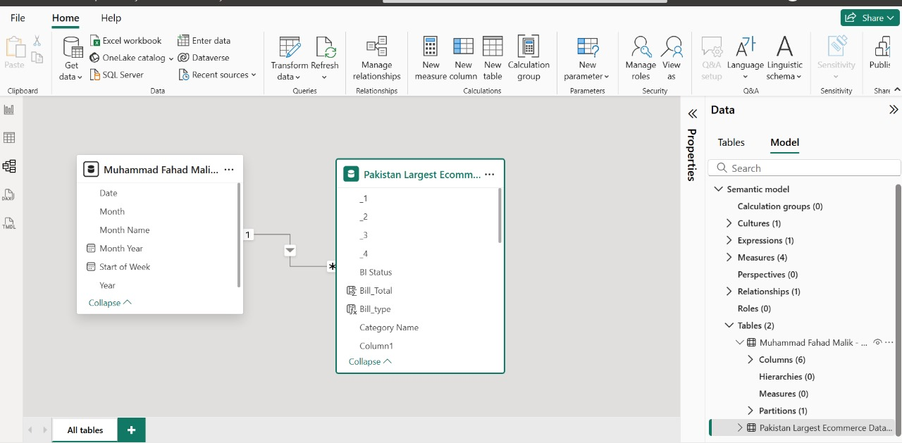

2. Activity 2: DAX Calculations
Here is the screenshots of activity 2.
- Calculated Column 1: Bill Total
Make column of bill total.

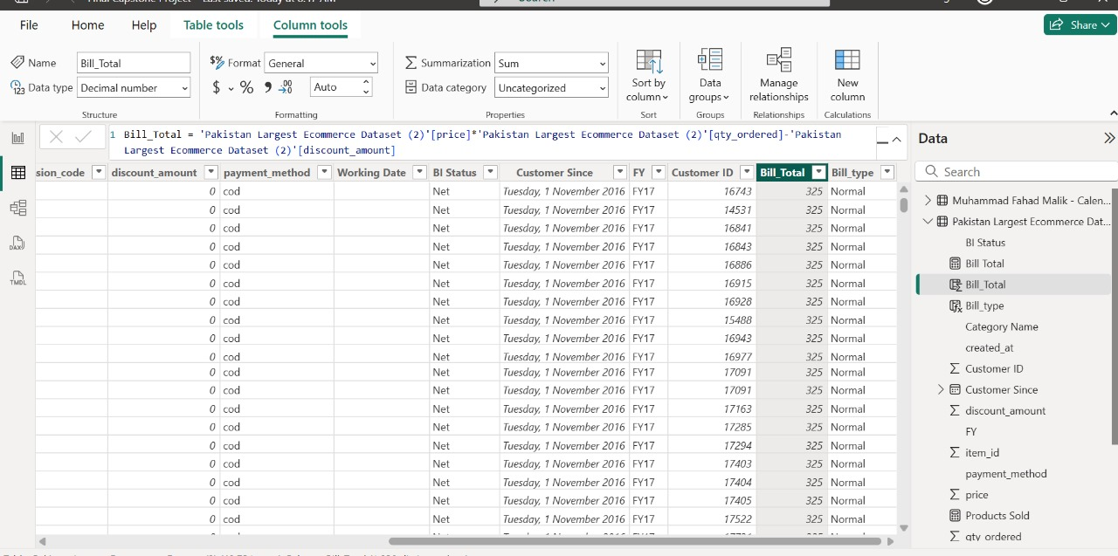

- Calculated Column 2: Bill Type
Make column of bill type.
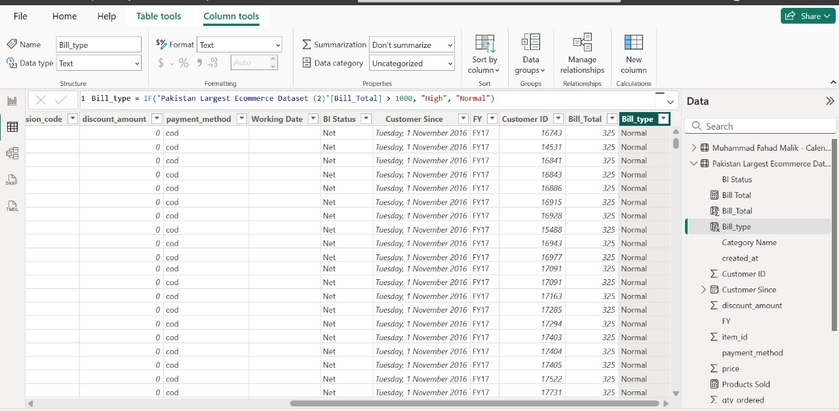

- Measure 1: Total Sales:
Make measures of total sales.

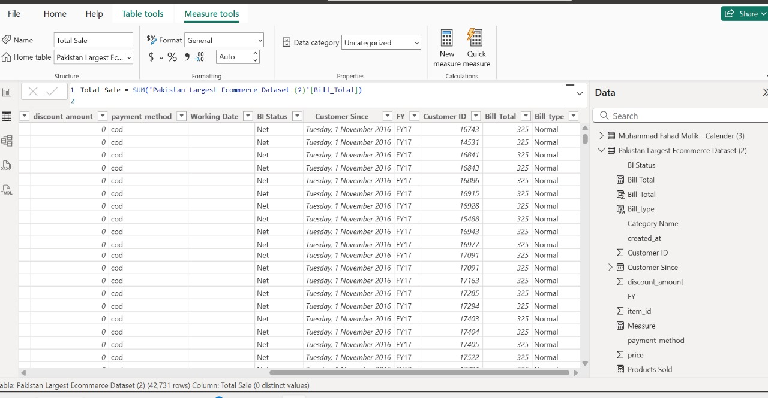

- Measure 2: Products Sold
Make measures of Product Sold.
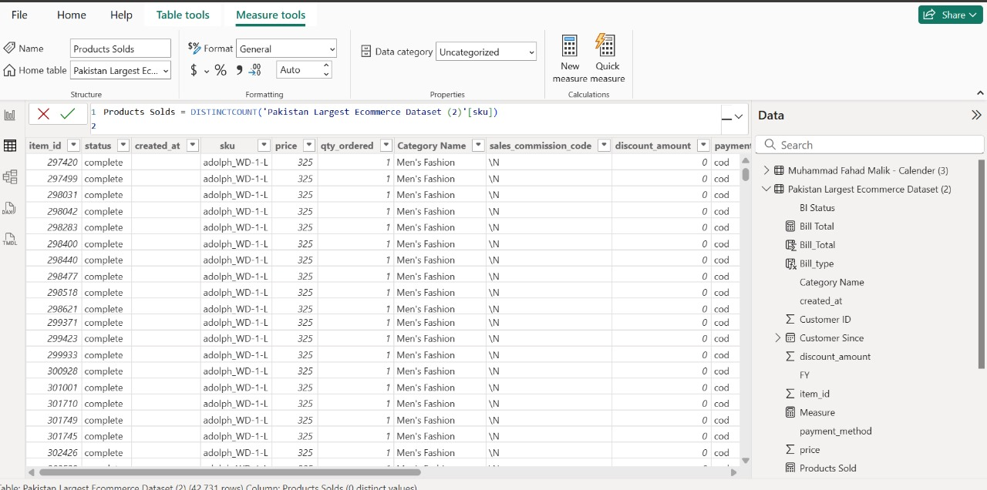

- Measure 3: Total Customers:
Make measures of total customers.

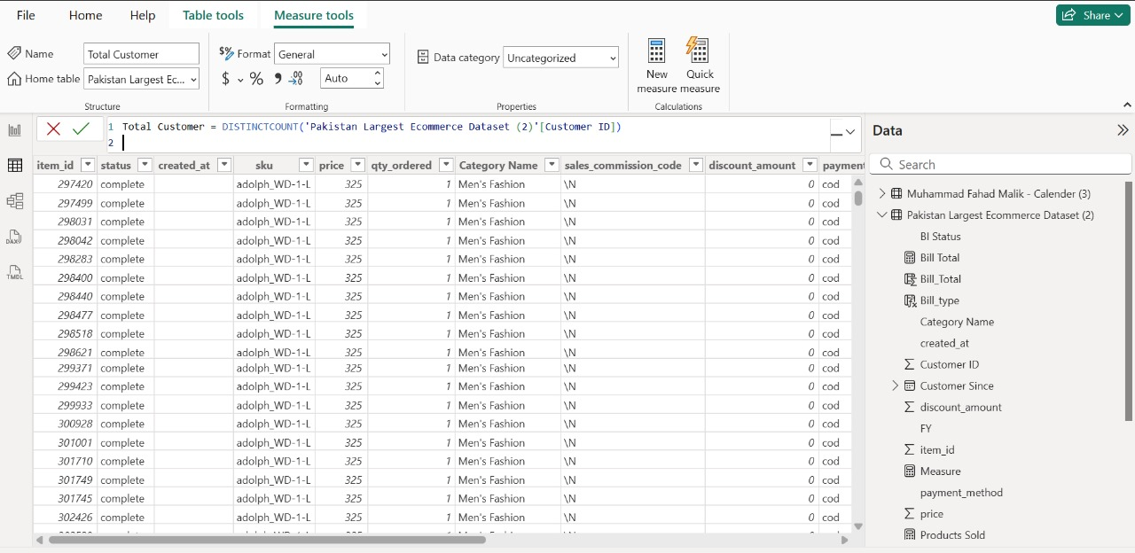

2. Activity 3: Dashboard Pages
Here is the screenshots of activity 3.
- Overview Page
This is about overview report of Pakistan largest E-commerce Data.
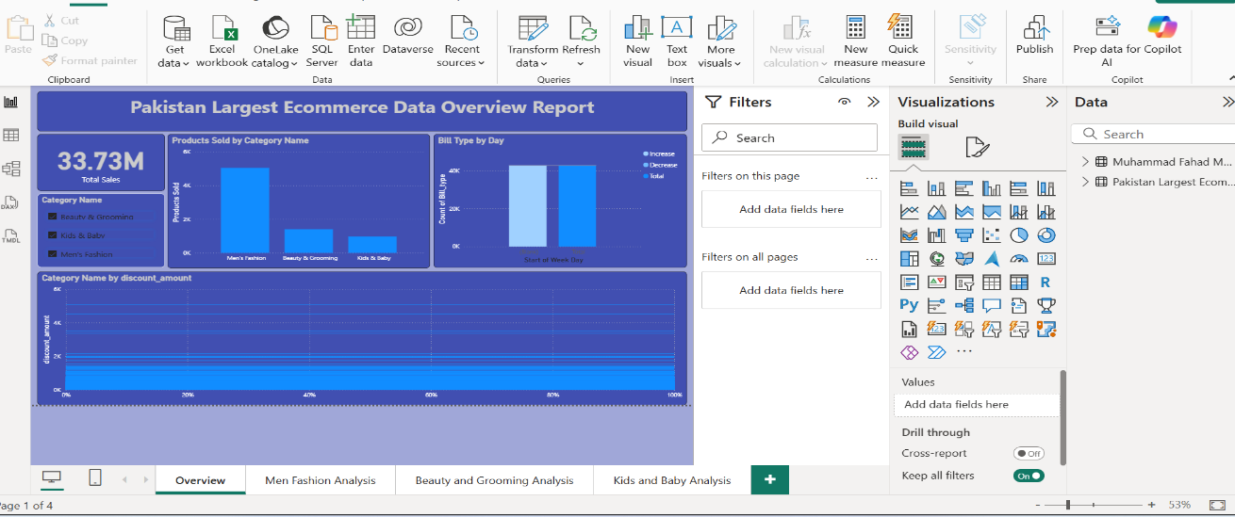

- Men’s Fashion Page:
Report about category of Men’s Fashion data.

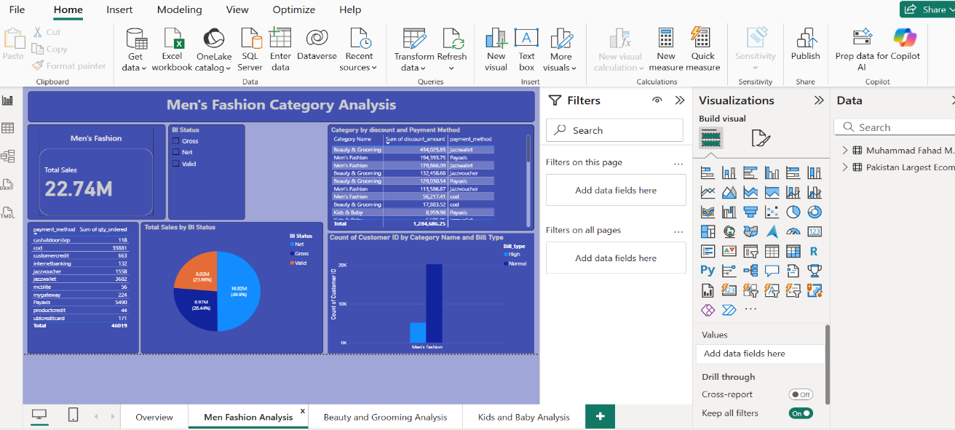

- Beauty & Grooming Page:
Report about category of Beauty & Gromming data.
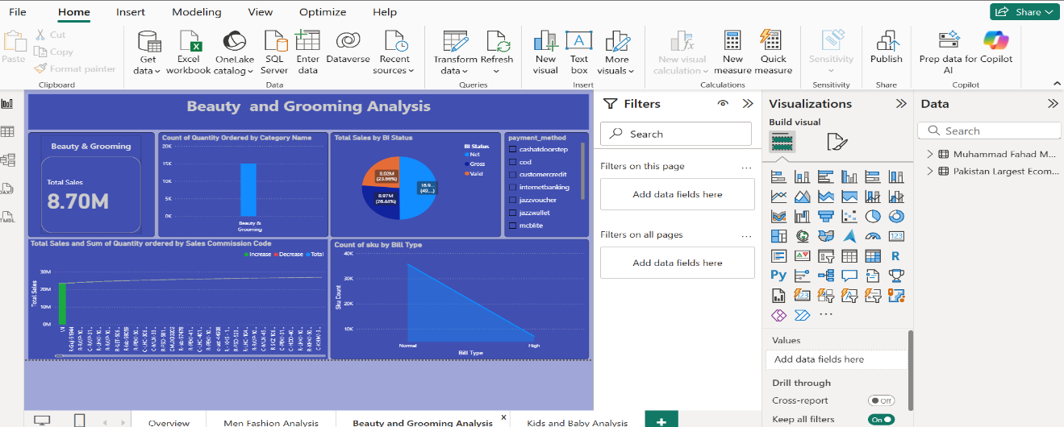
- Kids & Baby Page:
Report about category of Kids & Baby data.

